Name: ______________________________________

After being assigned a circuit, calculate the voltage drop for each resistor of your circuit.

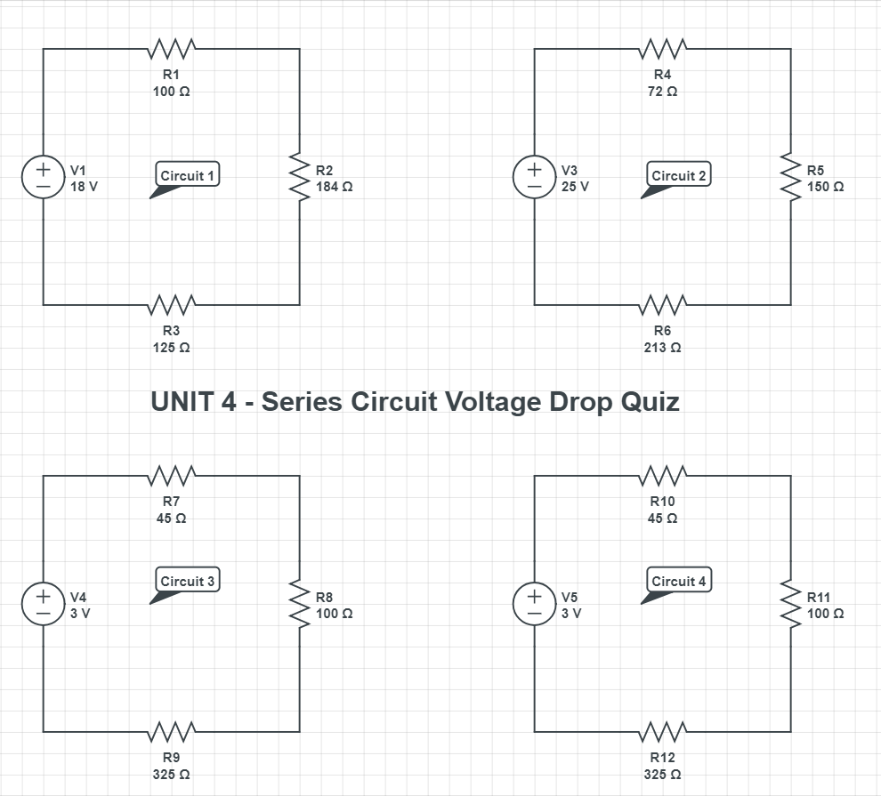

Assigned Circuit #: ___________

Voltage Drop at R__ : ___

Voltage Drop at R__ : ___

Voltage Drop at R__ : ___